**Assignment -3**

Python Programming

|  |  |
| --- | --- |
| Assignment Date | 12 October 2022 |
| Student Name | Janarthana Krishna V |
| Student Roll Number | 19BEC088 |
| Maximum Marks | 2 Marks |

**Question-1:**

Write python code for blinking LED and Traffic lights for Raspberry pi.Only python code is enough, no need to execute in raspberry pi.Note: you are allowed to use web search and complete the assignment.

**CODE**:

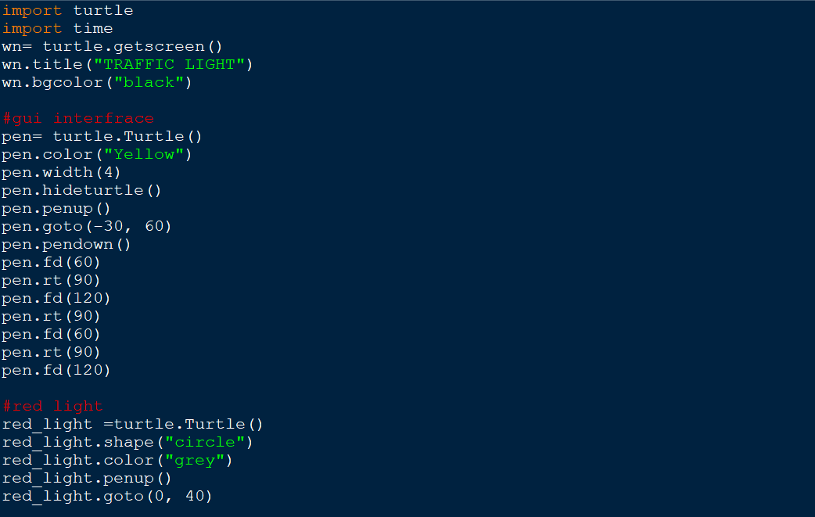

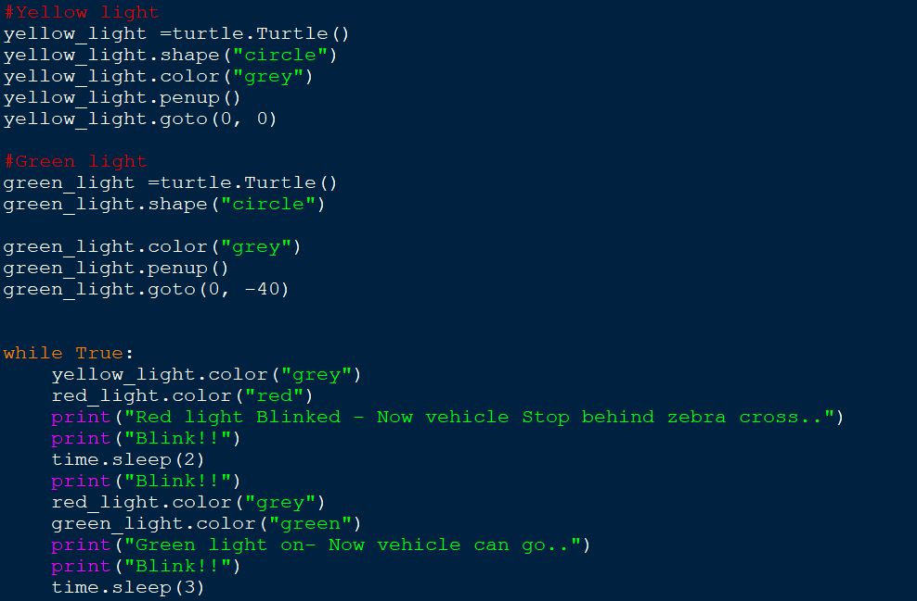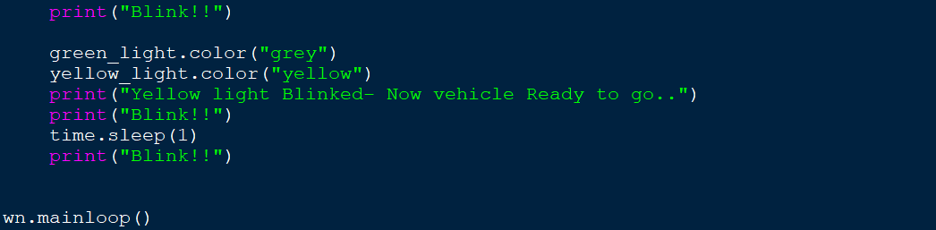

**OUTPUT:**

